7 Principal of Software Testing

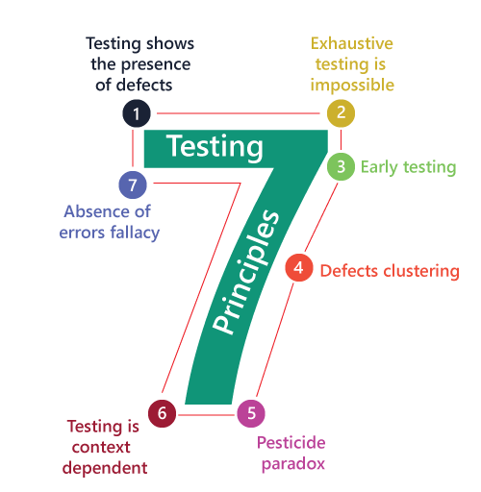

| **Manual Testing** | **Automated testing** |
| --- | --- |
| When a testcase is executed manually without an intervention of a tool is called manual testing. | When a testcase is executed with the help of a tool without much manual intervention is called automated testing. |
| Repetitive manual efforts are included. | Repetitive manual efforts may be avoided. |
| Human efforts in manual testing could be erroneous and time consuming. | Automation tests are faster and error free compared to the manual efforts. |
| Testing resources required are more for running every testcase manually thereby, adding to the investment in the resources. | Less testers are needed to execute automated tests using the designated automated tool(s) hence there is less investment in testing resources thus adding to the profitability. |
| Manual testing has to be limited to a small test coverage considering the timeline restrictions. Hence, there is a risk of skipping many test scenarios thus leading to risk of defect leakage as well. | Many different test scenarios can be automated and can be executed multiple times even under time and resource crisis hence leading to better test coverage and better quality of the deliverable. |

**Black-box testing**

It is carried out to test functionality of the program and also called 'Behavioral testing. The tester in

this case, has a set of input values and respective desired results. On providing input, if the output

matches with the desired results, the program is tested 'ok', and problematic otherwise.

In this testing method, the design and structure of the code are not known to the tester, and testing engineers and end users conduct this test on the software

**Black-box testing techniques:**

* Equivalence class -The input is divided into similar classes If oneelement of a class passes test, it is assumed that all the class is passed
* Boundary values- The input is divided into higher and lower end values. If these values pass the test, it is assumed that all values in between may pass too
* Cause-effect graphing In both previous methods, only one input valueat a time is tested. Cause (input) -Effect (output) is a testing technique where combinations of input values are tested in a systematic way.
* Pair-wise Testing -The behavior of software depends on multipleparameters. In pairwise testing, the multiple parameters are tested pair-wise for their different values
* State-based testing - The system changes state on provision of input. These systems are tested based on their states and input

**White-box testing**

It is conducted to test program and its implementation, in order to improve code efficiency or structure. It is also known as 'Structural testing.

In this testing method, the design and structure of the code are known to the tester Programmers

of the code conduct this test on the code.’

**White-box testing technique**

* Control-flow testing - The purpose of the control-flow testing to set uptest cases which covers all statements and branch conditions. The branch conditions are tested for both being true and false, so that all statements can be covered.
* Data-flow testing-- This testing technique emphasis to cover all the datavariables included in the program. It tests where the variables were declared and defined and where they were

## **Grey Box Testing**

Grey box testing is a software testing technique in which testers do not have complete knowledge about the product, they have limited information for internal functionality and code. They do have information about the requirement and also have the access to detailed design documents.

This testing technique is a combination of Black box testing and White box testing.

**Techniques For Grey Box Testing**

1. Matrix testing
2. Regression testing
3. Orthogonal Array testing
4. Pattern Testing

**#1) Matrix Testing**

Software developers provide all the variables in a program along with the technical and business risks that are linked with them. The matrix testing technique tests the risks defined by the developers.

Matrix technique states all the used variables in a program. This technique helps to identify and remove the variables which are not being used in the program and in turn, helps to increase the speed of the software.

**#2) Regression Testing**

Regression testing is performed when any change is done in the software or any defect is fixed. It is done to ensure that a new change or fix done has not impacted any existing functionality of the software.

**#3)**[**Orthogonal Array Testing or OAT**](https://www.softwaretestinghelp.com/combinational-test-technique-2/)

This testing technique is used more for complex functionalities or applications, as this technique is utilized when maximum coverage of code is required with minimum test cases and has large test data with n number of combinations.

**#4) Pattern Testing**

Pattern Testing is performed based on the previous defects found in the software. Defect record is analyzed for the cause of defects and test cases are created keeping the defects and their cause in knowledge to find defect before the software goes into production.

|  |  |
| --- | --- |
| Black -Box Testing | White-box Testing |
| 1. The internal workings of an application need not be known. 2. Also known as closed-box testing, data-driven testing, or functional testing. 3. Performed by end-users and also by testers and developers. 4. Testing is based on external expectations - Internal behavior of the application is unknown. 5. It is exhaustive and the least time-consuming. 6. Not suited for algorithm testing. 7. This can only be done by trial-and-error method. | 1. Tester has full knowledge of the internal workings of the application. 2. Also known as clear-box testing, structural testing, or code-based testing. 3. Normally done by testers and developers. 4. Internal workings are fully known and the tester can design test data accordingly. 5. The most exhaustive and time-consuming type of testing. 6. Suited for algorithm testing. 7. Data domains and internal   boundaries can be better  tested. |

| **Verification** | **Validation** |
| --- | --- |
| Verification means checking the documents, languages, designs, and other programming things. | Validation means testing the actual product.. |
| Verification does not involve the execution of the code | Validation involves the execution. |
| Its before validation | After verification |
| It is considered static testing | It is considered dynamic testing. |
| Verification uses methods such as walkthroughs, reviews, desk-checking, and inspection | Validation uses a method such as White Box Testing, Black Box Testing, etc. |
| It has the ability to detect errors quickly  It includes checking documents delivered by humans. | It can only detect errors that could not be determined by the verification method.  It includes the execution of a program executed by a computer. |

STLC

18 oct

STLC

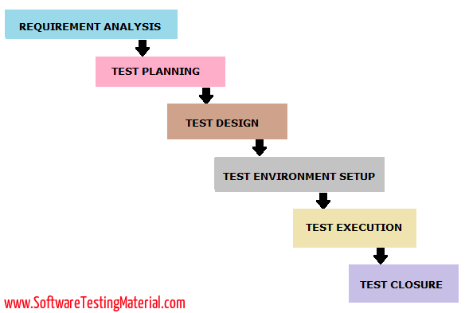

19 Oct. 22

SRS Document

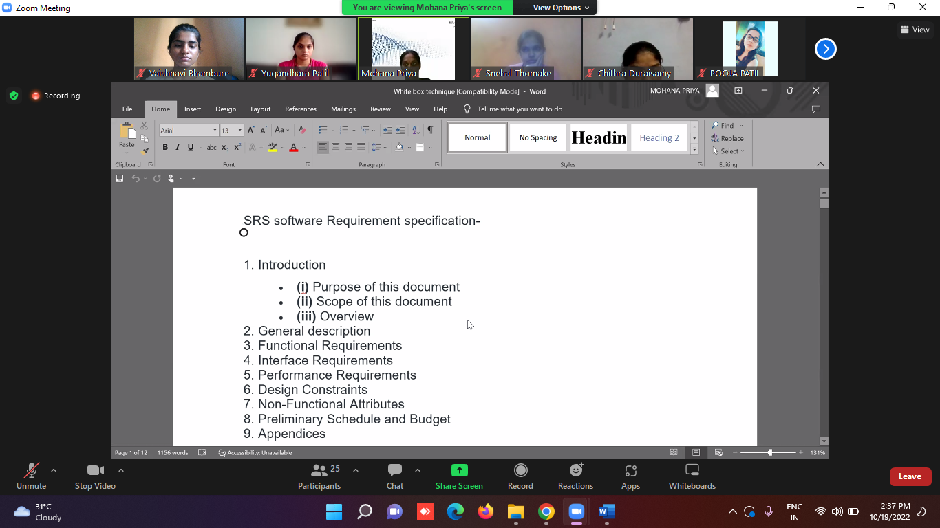

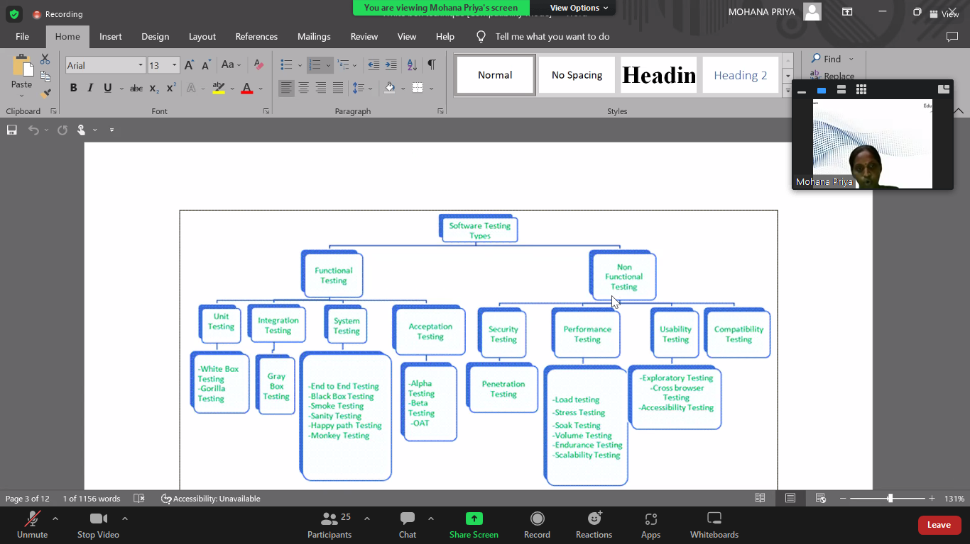

## **Test Approach:**

A test approach is the test strategy implementation of a project, defines how testing would be carried out. Test approach has two techniques:

* **Proactive -**An approach in which the test design process is initiated as early as possible in order to find and fix the defects before the build is created.
* **Reactive -**An approach in which the testing is not started until after design and coding are completed.

**What is a Test case?**

A test case has components that describe input, action, and an expected response, in order to determine if a feature of an application works correctly.

**Test Scenario**

**Any software functionality/feature that can be tested is said to be a Test Scenario.**The end-user perspective is considered while writing any test scenarios.

**Test Suite**

Test suite is a container that has a set of tests which helps testers in executing and reporting the test execution status. It can take any of the three states namely Active, In progress and completed

**Test Basis**

Test basis is defined as the source of information or the document that is needed to write test cases and also for test analysis.

Test basis should be well defined and adequately structured so that one can easily identify test conditions from which test cases can be derived.

## **Typical Test Basis:**

* Requirement document
* Test Plan
* Codes Repository
* Business Requirement

## **What is Test Automation?**

Software Test automation makes use of specialized tools to control the execution of tests and compares the actual results against the expected result. Usually, regression tests, which are repetitive actions, are automated.

Testing Tools not only helps us to perform regression tests but also helps us to automate data set up generation, product installation, GUI interaction, defect logging, etc. Automation tools are used for both Functional and Non-Functional testing.